THE TABLEAU HR SCORECARD

*I am M.petchiammal.My team members are s.priyatharshini ,s.jaya and p.kalaivani.THE TABLEAU HR SCORECARD IS THE TEAM OF MY PROJECT*.

INTRODUCTION:

THE TABABLEAU HR SCORECARD and ideas says that think does and feels in the brainstorm map. Then create empathy map and our own ideas creation a graph about our project in using by our ideas. Now we see our brainstorm and empathy map. Then now about our project ideas.

DEFINITION:

EMPATHY MAP

BRAINSTORM

EMPATHY MAP:

EMPATHY MAP COLLECTED BY OUR TEAM MEMBERS OWN IDEAS AND THINK ABOUT OUR SCORECARD.

1) TO ANSWER WHY EMPLOYEE RETENTION IS HIGH IN YOUR ORGANIZATION AND WHAT ARE THE FACTORS BEHIND THE SAME.

2) HR ANALYTICS IDENTIFIES THE HIDDEN PATTERNS AND TRENDS.

3)HR ANALYTICS MAKE USE OF DIFFERENT DATA TO SUGGEST WAYS TO DECREASE THE ATTRITION RATE.

4)THE HR SCOREBOARD IS A STRATEGIC HR MEASUREMENT SYSTEM THAT HELPS TO MEASURE, MANAGE AND IMPROVE THE ROLE.

5)HR METRICS AND KPIs ARE THE TOOLS AND CALCULATIONS THAT HUMAN RESOURCE DEPARTMENTS.

6)THERE ARE SEVEN STEPS TO CREATE THE BALANCED SCORECARD AND FOUR LEVELS IN HR METERICS .

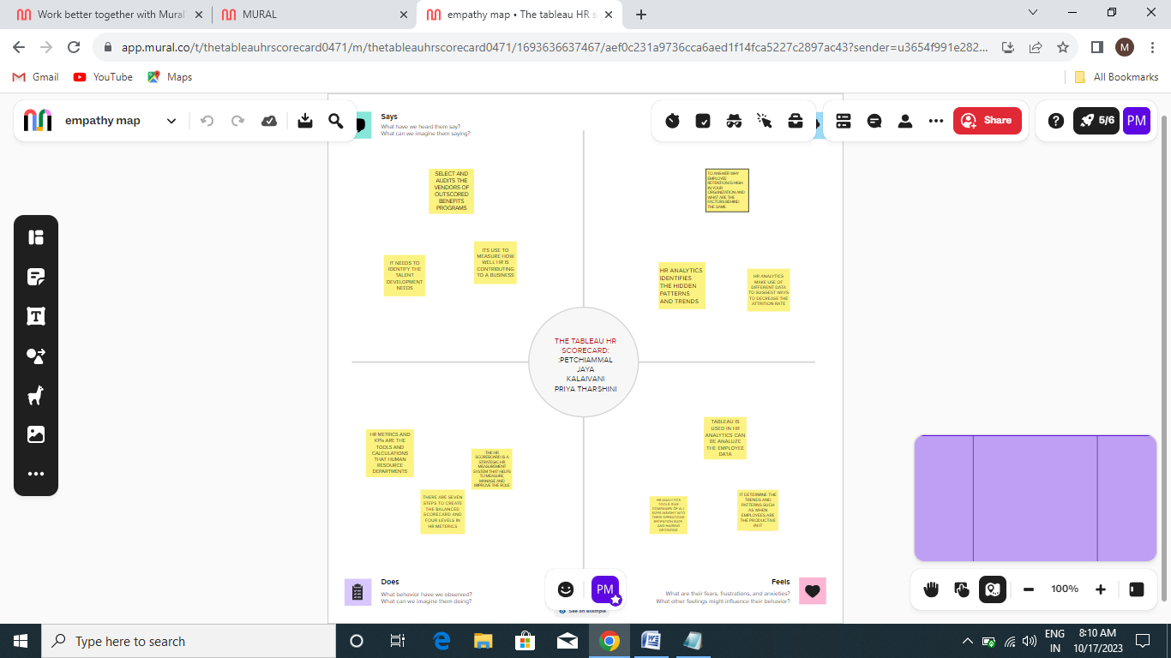

BRAINSTORM:

BRAIN STORM COLLECTED BY OUR TEAM MEMBERS OWN IDEAS AND THINK ABOUT OUR SCORECARD.

1) IT NEEDS TO IDENTIFY THE TALENT DEVELOPMENT NEEDS.

2) SELECT AND AUDITS THE VENDORS OF OUTSCORED BENEFITS PROGRAMS.

3 )ITS USE TO MEASURE HOW WELL HR IS CONTRIBUTING TO A BUSINESS.

4) TABLEAU IS USED IN HR ANALYTICS CAN BE ANALUZE THE EMPLOYEE DATA.

5 )HR ANALYTICS TOOLS GIVE COMPANIES OF ALL SIZES INSIGHT INTO THEIR OPERATIONS, RETENTION RATE, AND HAIRING DECISIONS.

6) IT DETERMINE THE TRENDS AND PATTERNS SUCH AS WHEN EMPLOYEES ARE THE PRODUCTIVE IN IT.

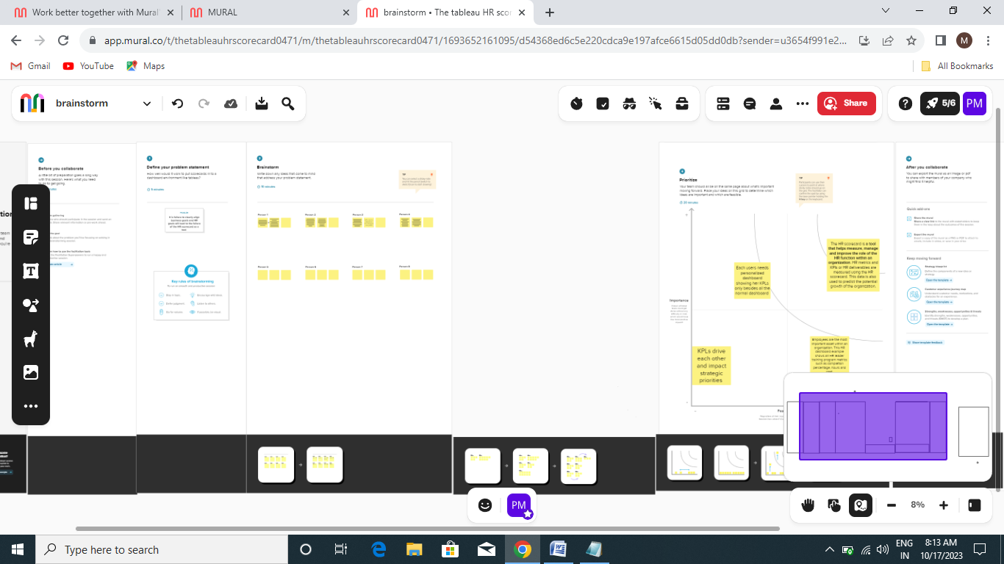

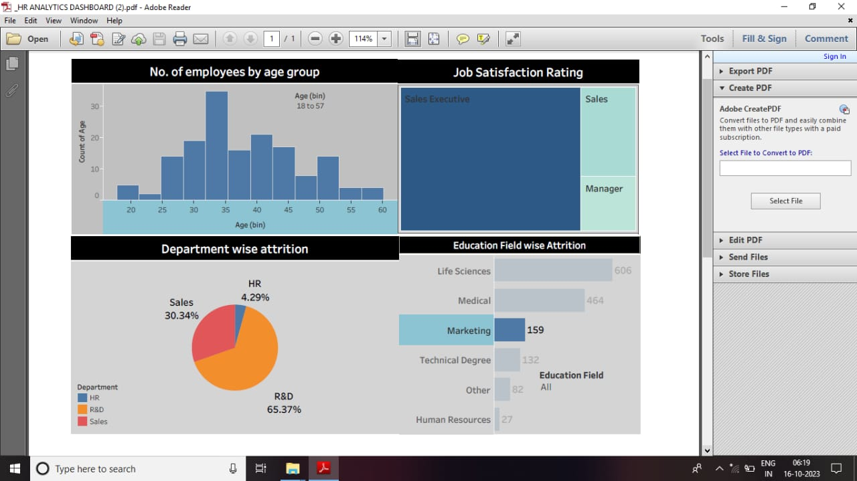

DASHBOARD:

IN THIS DASHBOARD WE COLLECT OUR DOING VISUALIZATION SHEET IN OUR DASHBOARD THEN SET ALL SUITABLE VALES FOR OUR PROJECT.

STORY:

IN THIS DASHBOARD WE COLLECT OUR DOING VISUALIZATION SHEET IN OUR DASHBOARD THEN SET ALL SUITABLE VALES FOR OUR PROJECT. LIKE FIX OTHER DATA VISUALIZATION SHEETS.

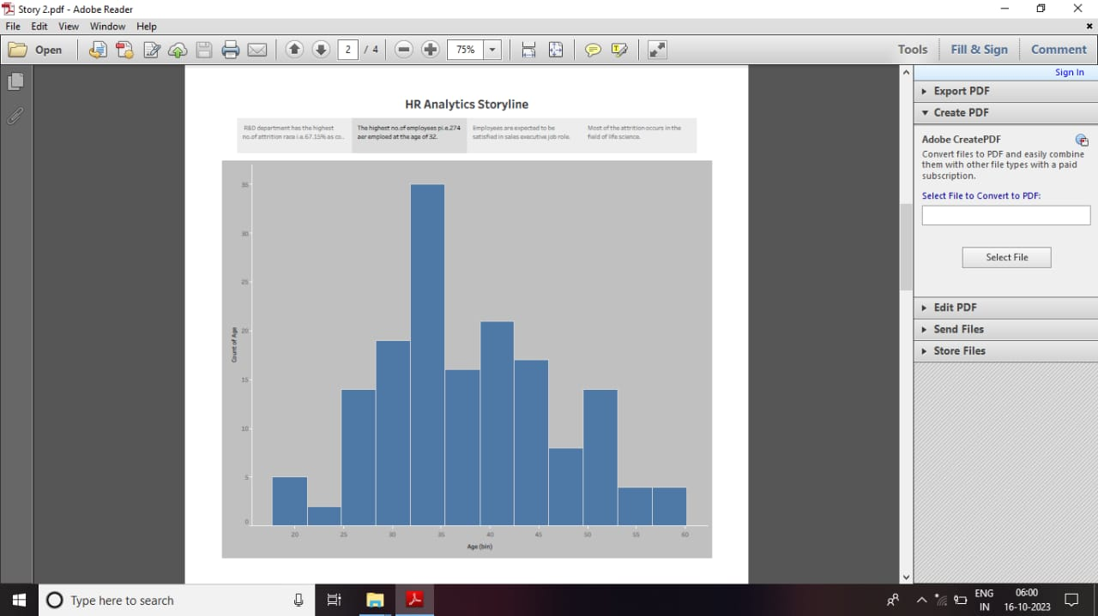

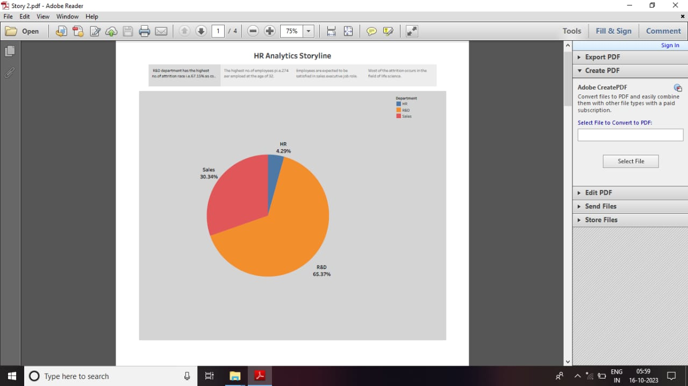 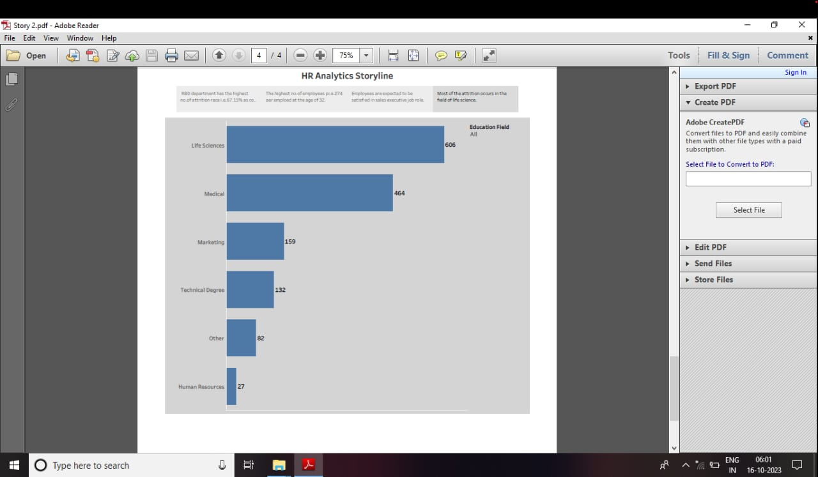 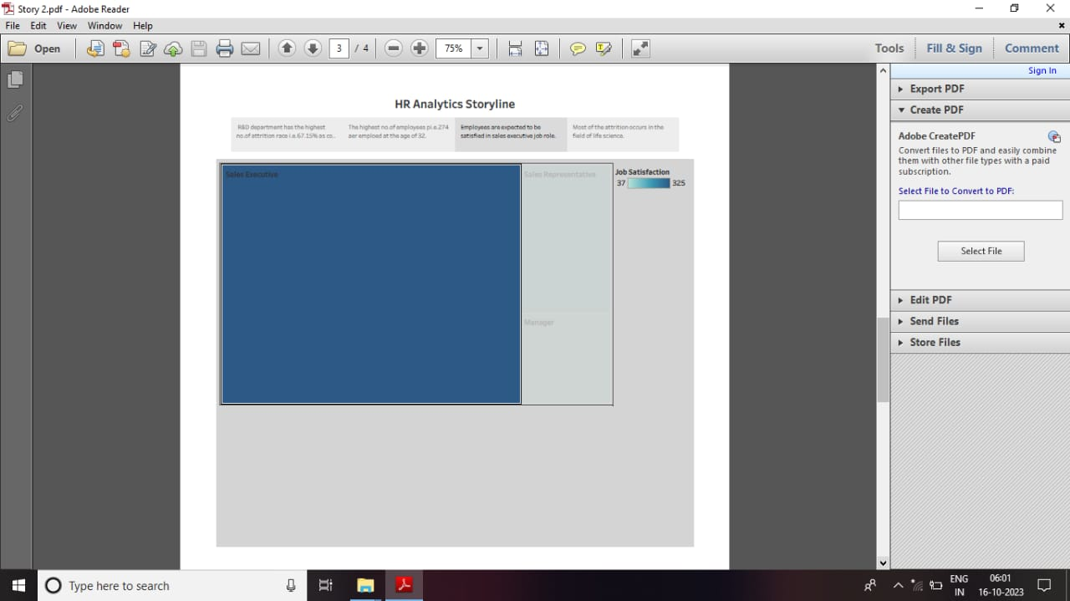

CONCLUSION:

IN THIS THE TABLEAU HR SCORECARD WAS SAYS NUMBER OF EMPLOYEES AGE GROUP AND THEIR JOB STATISFACTION WISE ATTRITION ARE MAY WELL BE SUBJECT TO SUCH OBJECTIONS. THIS ALL THE ONTENTS ABOUT THIS SCORECARD.

THANK YOU!!!